****Tarlac State University

**COLLEGE OF COMPUTER STUDIES**

Case Study

in

Integrative Programming Technology 2

Submitted By:

**Student 1**

**Student 2**

**Student 3**

Submitted To:

**Subject Teacher**

Date: []

Table of Contents

A. Definition 3

B. Case Analysis #1 4

B.1 Problem 4

B.2 Solution/Implementation 4

B.3 Explanation 4

C. Case Analysis #2 5

C.1 Problem 5

C.2 Solution/Implementation 5

C.3 Explanation 5

D. References 6

# Definition

The Lab Quiz#2 you did (Static Website) upload the documentation and files in your GitHub repository and add a minimum of 3 more webpages to add in your repository during the development use Git and GitHub and create a documentation of all.

**For the development of the Portfolio Webpages using (Git and GitHub) Issues, Pull Request, Milestone, Branching**

**Quiz # 1 LAB: Portfolio**

**Portfolio Web Pages Upload to GitHub Using Git**

**Requirements:**

* Each member in your group will need to upload **a webpage**
* Create a **Pull Request** for each member in Github with comments.
* Create an **Issue** for each member in Github and comment.
* Create a **Milestone** for the group in Github.
* Create a branch for each member and merge it with your master in Github.

**Define and describe how you use of each command with screenshot in your case study.**

* Git clone
* Git Pull
* Git Push
* Git Fetch
* Git Merge
* Issue
* Pull Request
* Milestone
* Branch

**Note: List the contributions of your group members**

# Case Analysis (Git and GitHub Workflow)

## Documentation

Cloned the remote repository into my local repository

Issue –

Milestone

Branch

Git Pull - Fetch from and integrate with another repository or a local branch

Git Push – Update remote refs along with associated objects

Git merge – Join two or more development histories together

Commits

Git logs

Portolfio

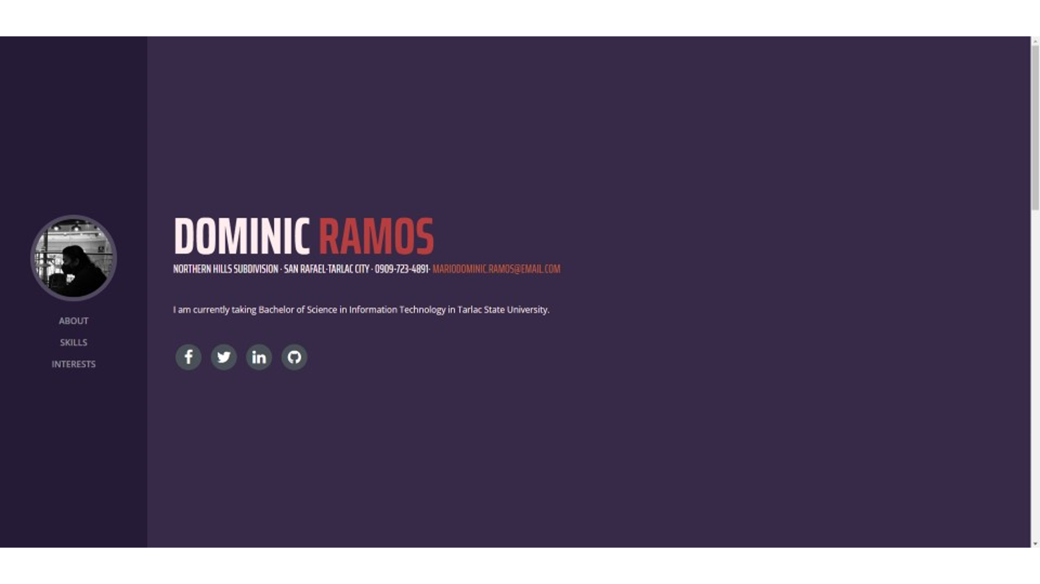



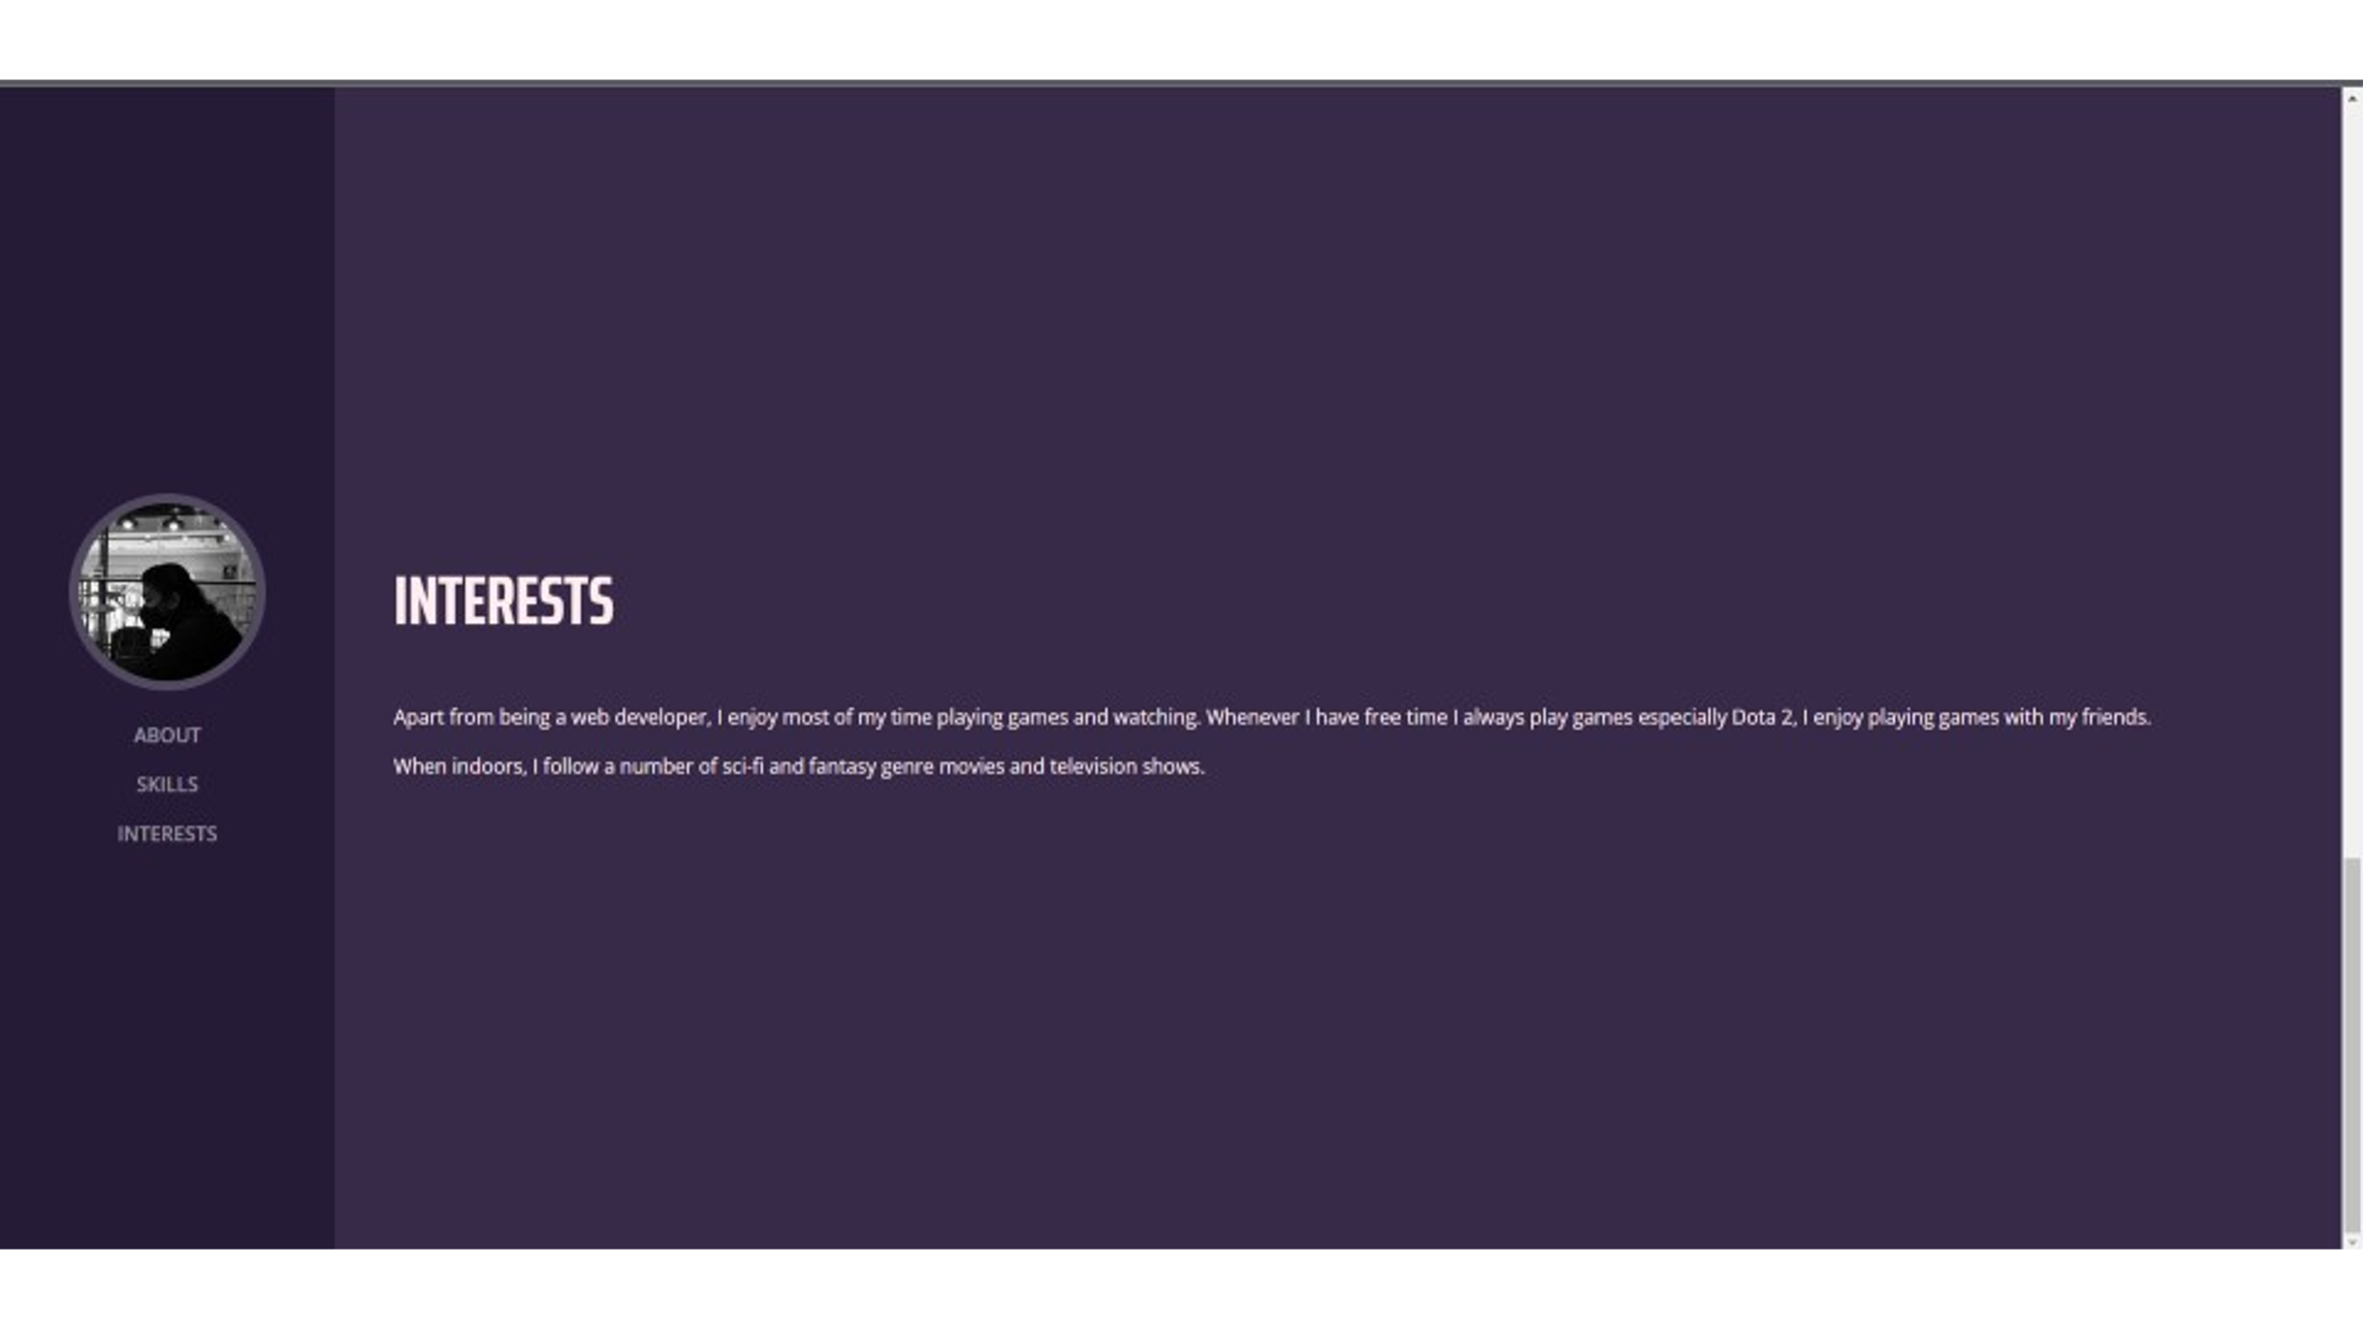

# References

[1] “Resume - A Bootstrap 4, Simple Yet Exquisite CV Template,” *ThemeWagon*. https://themewagon.com/themes/free-bootstrap-4-cv-template-download/ (accessed Oct. 22, 2022).

[2] “Resume - Start Bootstrap Theme,” *technext.github.io*. https://technext.github.io/resume-bootstrap4/ (accessed Oct. 22, 2022).

‌  
Note: List the contributions of your group members

De Almeida, Carlos: Contributed on executing the command requirements and documentation.

Piñon, Patricia Paula: Contributed on executing the command requirements and documentation.

Viado, Anna Mikaela: Contributed on executing the command requirements and documentation.

Ramos, Mario Dominic: Contributed on executing the command requirements and documentation.

**Grade Matrix:**

Git Command : **20%**

GitHub Implement : **20%**

Documentation : **40%**

Webpage (Development) : **30%**

**100%**